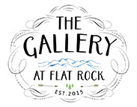
CONTACT: Suzanne Camarata
info@galleryflatrock.com
For Immediate Release
May 28, 2020
CONTACT: Suzanne Camarata Ball
info@galleryflatrock.com
What: “A Cause for Big Paws” - Celebrating the Big Dogs with Paintings by Marsha Hammel
When: 11 a.m.- 6 p.m. July 2 Opening Reception by ticketed reservation; July 3-10 daily viewing by appointment only.
Where: M.Hammel Studio, 1901 Kanuga Rd., Hendersonville, N.C.
How much: Tickets to July 2 event are $20 each; include an original sketch by Marsha Hammel and a doggie bag of goodies; July 3-10 exhibition is free and open to the public by appointment only.
Information, reservations and tickets: 828-698-7000 or info@galleryflatrock.com

A Cause for Big Paws
Celebrating the Big Dogs Through Art and Adoption
July 2-10, 2020

The Gallery at Flat Rock is excited to announce a dog-friendly event and exhibition celebrating adoptable canines weighing 50 pounds or more. “A Cause for Big Paws” is the result of a partnership between the Blue Ridge Humane Society, Barkers Anonymous and The Gallery at Flat Rock artist Marsha Hammel; they have joined forces to highlight the loving big dogs at BRHS that are currently seeking forever homes. The exhibition of Hammel’s work in her Hendersonville studio will feature a reserved ticketed opening party with all proceeds going to BRHS.
“We wanted to draw attention to big dogs, in that big dogs are slower to be adopted than small dogs,” said Marsha Hammel. “We’re celebrating the joys of living with big dogs.”
“A Cause for Big Paws” will showcase new paintings inspired by big dogs at M.Hammel Studio. A dog-friendly opening on July 2 from 11 a.m. to 6 p.m. at the studio will include treats for humans and dogs, as well as a chance for attendees to receive an original sketch drawn by Hammel, created on-site at the event.

The Gallery at Flat Rock Presents “A Cause for Big Paws”
(Page 2 of 2)

To maintain proper social distancing, this ticketed event is open only by reservation to individuals and small groups. Barkers Anonymous will provide the goodies and treats for pets. Tickets to this event are $20 each with part of the proceeds to fund the mission of Blue Ridge Humane Society.
M.Hammel Studio, located at 1901 Kanuga Rd., will be open by appointment daily from July 3 – 10, for exhibit viewing. For tickets and reservations, contact The Gallery at Flat Rock at 828-698-7000 or email info@galleryflatrock.com.

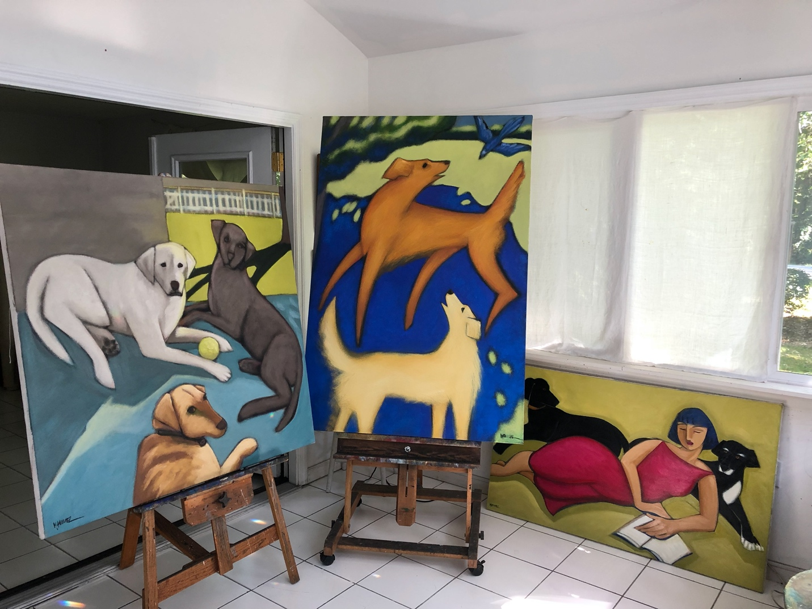

The Gallery at Flat Rock represents finely curated art and craft, and is located in Flat Rock Square at 2702-A Greenville Highway in Flat Rock, North Carolina. Gallery hours are currently Thursdays - Sundays 11 a.m. to 3 p.m.; or by appointment. To learn more, please visit the gallery website at galleryflatrock.com or call the gallery at 828-698-7000.
###

